Barguna District,Bangladesh
(Established as a district: 28th Feb,1984)
N
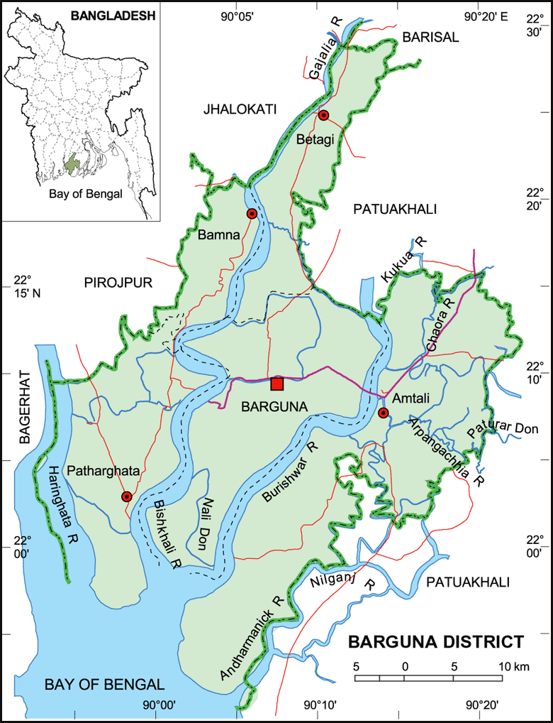
S
Fig-1: Map of Barguna District

Situtation : Southern part of Bangladesh.
Total Population: 8,92,781
Literacy Rate: 62.10%
Upazilla: 06
Unions: 42.

Sl.No. | Upazilla | Area(sq.km) | No.of unions | Population  (2011)
1. | Barguna Sadar | 554.39 | 10 | 2,19,729
2. | Amtoli | 720.76 | 07 | 2,44,438,
3. | Bamna | 101.05 | 04 | 79,564
4. | Betagi | 167.75 | 07 | 1,10,926
5. | Pathorghata | 387.36 | 07 | 1,34,635
6. | Taltoli | 258.94 | 07 | 88,004
 | Total |  | 42 | 8,92,781

Health Institutions.
1. Sadar Hospital:100 bedded.
2. Upazilla Health complex: 6 (5 of them are 50 Bedded, Taltoli-20
Bedded)
3. Community Clinic: 129
4. Rural Dispensary: 08
5. HFWC: 15

Status in HSS Score From Jan-July.
Name | Janu | Feb | Mar | April | May | June | July
Barguna D-Hospi | 03 | 07 | 19 | 22 | 21 | 16 | 19
Amtoli UHC | 319 | 200 | 255 | 298 | 207 | 368 | 353
BetagiUHC | 306 | 314 | 304 | 332 | 340 | 337 | 341
BamnaUHC | 221 | 162 | 290 | 230 | 279 | 277 | 279
PathorghataUHC | 209 | 291 | 347 | 258 | 248 | 270 | 385
Taltoli UHC | - | - | - | - | - | - | -

Visit Report: Amtoli Upazila Health Complex, Barguna
Date of Visit: 25/08/22; Time: 8:45 AM.
Visitor: Dr. Md. Emdadul Haque, National Consultant (HEU) &
Dr. Nazmur Rahman Sajib, Junior National Consultant (HEU)

2. The infra-structure of this Upazila Health Complex is 50 bedded. The physical condition of the hospital building is good. The UHC is situated close to the high way. There are 7 unions under this UHC.
2. We arrived at 8:45 am in the health complex. But no medical officer except EMO was present in the health complex.

3. We met with the RMO and other Medical Officers, discuss with them about the overall situation of health complex. The post of Gynae and Anaesthesia consultant was vacant, so caesarean section is not performed.
4. We visited outdoor of the Upazila Health Complex of . The outdoor was crowded with patients. We observed OPD, Emergency, labour room, pathology and pharmacy department. There are two medical technologist (Lab). The information display system was better than any other UHC of Barguna district, but the health education system is weak.
5. Cleanliness of the hospital premises and indoor was satisfactory. There is separate operation theatre but not functioning.
6. There is no cycle stand close to the main gate. There are many motorcycles parked within corridor.
7.The roof of the health complex is not clean. There are many bushes and unwanted hospital beds and other items on the roof.
8.There are many spaces in emergency, SSK Booth and Pharmacy can easily be established there.
9.There are many “Danbox” throughout the UHC, and advised for removing those immediately.
10.The UHC was awarded by ” Health Ministered Award ”in 2015.

Health Profile of Amtoli UHC, Amtoli, Barguna
Total population: 244,438
Union: 7 Sub-centre: 2 FWC: 7 Community Clinic: 29
Human Resources: 50 Bedded Hospital:
Sl. | Designation | No. of Post | Present | Vacant
1. | UH&FPO | 1 | 1 | 0
2. | Junior Consultant | 11 | 0 | 11
3. | Medical Officer | 2 | 2 | 0
4. | Medical Officer (OSD) | 7 | 6 | 1
5. | Nurses | 30 | 30 | 0
6. | Mid wives | 4 | 4 | 0
7. | Medical Technologist (Lab) | 3 | 2 | 1
8. | MT EPI | 1 | 1 | 0
9. | Dental Technologist | 1 | 0 | 1
10. | MT (Radiology) | 1 | 1 | 0
11. | SACMO | 4 | 4
12. | Health Inspector (HI) | 2 | 0 | 2
13. | Assist. Health Inspector | 7 | 7
14. | Health Assistant | 21 | 19 | 2
15. | CHCP | 29 | 29
16 | Head Assistant | 1 | 0 | 1
18. | Accountant/Statistician | 2 | 1 | 1
19. | MLSS | 4 | 2 | 2
20. | Cleaner | 5 | 4 | 1
21. | FWA | 21 | 21 | 0
22. | Outsourcing: Cleaner, Cook, Guard, Ward boy, Aya. | 4 | 1 | 3

Status in HSS Score From Jan-July.
Name | Janu | Feb | Mar | April | May | June | July
Barguna D-Hospi | 03 | 07 | 19 | 22 | 21 | 16 | 19
Amtoli UHC | 319 | 200 | 255 | 298 | 207 | 368 | 353
BetagiUHC | 306 | 314 | 304 | 332 | 340 | 337 | 341
BamnaUHC | 221 | 162 | 290 | 230 | 279 | 277 | 279
PathorghataUHC | 209 | 291 | 347 | 258 | 248 | 270 | 385
Taltoli UHC | - | - | - | - | - | - | -

Status of Building Blocks of C-J Model in the Amtoli UHC:
Sl | Criteria of C-J Model | Best | Good | Weak
 | Cycle stand close to the main gate |  |  | √
 | Health Education |  | √
 | Cleanliness & beautification | √
 | Separation of patients in out door & indoor |  |  | √
 | Blood doner list with 24/7 B.T facility |  | √
 | Birth- death recording |  |  | √
 | Reception Desk |  |  | √
 | Developed Emergency Dept. |  | √
 | 5S –KAIZEN implementation. |  | √
 | Community Participation. |  | √
 | Hospital activities Display |  | √
 | Corner based service. |  | √
 | Cash counter for receiving Govt money. |  |  | √
 | Devolped maternal health/labour word. |  |  | √
 | Devolped paediatric health |  |  | √
 | Position in HSS score  (Best= <100; Good= 101-200; Weak= >200) |  |  | √
 | Power point Presentation &Video on UHC |  | √
 | Knowledge about 8th Five Year plan & SDG. |  |  | √
 | Zero-Tollarance on corruption |  | √

Recommendations:
1. For better office management, the post of Head Assistant and Statistician is very important. Both the post is lying vacant. It should be filled up immediately.
2. Cleanliness and beautification is satisfactiry. The local Powroshova must take part in waste management.
3. There is no OT room in the health complex.
4. Labor room is welfunctioning.
5. Condemetion Board should work to destory all unwanted items.
6.All the vacant posts of 4th class should be fulfilled immediataely.
7. Medical Technologist (Dental) is necessary for dental deptt.
8. Replication of C-J model will help in development of the quality of care and it should be followed properly.
11. All the post of consultants especially Gynae consultant and Anesthesia should be filled up immediately .
12. Radiogical service is not functioning.Vaccant post of radiographer shoul be fulfilled.
14. There should be a Complains and Suggestion box in front of UH&FPO room
15. The roof of the health complex building should be clean.
16. There is availability of safe drinking water.
17.All the “Danbox” of the UHC, should be remove.
18.By dividing of a large room close to Emergency Deptt. a site for SSK Booth& a Pharmacy built is possible.

Visit Report: Bamna Upazila Health Complex, Barguna
Date of Visit: 24/08/22; Time: 9:45 AM.
Visitor: Dr. Md. Emdadul Haque, National Consultant (HEU) &
Dr. Nazmur Rahman Sajib, Junior National Consultant (HEU)

1. The infra-structure of this Upazila Health Complex is 50 bedded. The physical condition of the hospital building is good. The UHC is 37km. away from Civil Surgeon Office, Barguna. There are 4 unions under this UHC.
2. We arrived at 9:45 am in the health complex. But UH&FPO and all the medical officers were present in the health complex.
3. We met with the UH&FPO, RMO and other Medical Officers, discuss with them about the overall situation of the health complex. The post of Gynae and Anaesthesia consultant were vacant, so caesarean section is not being performed.
4. We visited outdoor of the Upazila Health Complex of Bamna. The outdoor was crowded with patients. We also observed Emergency, labour room, pathology and pharmacy department. The information display system was good but not updated. There was no effective health education system.
5. Cleanliness of the hospital premises and indoor was satisfactory. There is separate operation theatre having no equipment.
6. There is no cycle stand close to the main gate. There are many motorcycles parked within the premises.
7. The roof of the health complex is not clean. There are many bushes on the roof.
8.There spaces in emergency is congested. But SSK Booth and Pharmacy can be established close to the emergency department.
9.There are many “Danbox” throughout the UHC, and advised for removing those immediately.
10. There is a well decorated conference room in the UHC.

Health Profile of Bamna UHC, Bamna, Barguna
Total population: 94,036
Union: 4 Sub-centre: 0 FWC: 4 Community Clinic: 08
Human Resources: 50 Bedded Hospital:
Sl. | Designation | No. of Post | Present | Vacant
1. | UH&FPO | 1 | 1 | 0
2. | Junior Consultant | 11 | 0 | 11
3. | Medical Officer | 2 | 2 | 0
4. | Medical Officer (OSD) | 10 | 10 | 0
5. | Nurses | 21 | 20 | 01
6. | Mid wives | 04 | 04 | 0
7. | Medical Technologist (Lab) | 2 | 0 (1 deputed from other UHC) | 2
8. | MT EPI | 1 | 1 | 0
9. | Dental Technologist | 1 | 0
10. | MT (Radiology) | 1 | 0
11. | SACMO | 3 | 3
12. | Health Inspector (HI) | 1 | 1
13. | Assist. Health Inspector | 4 | 4
14. | Health Assistant | 18 | 18
15. | CHCP | 09 | 08
16 | Head Assistant | 01 | 0 | 1deputed
18. | Accountant/Statistician | 2 | 1(No accountant) | 1
19. | MLSS | 4 | 2 | 2
20. | Cleaner | 5 | 2 | 3
21. | Guard | 02 | 01 | 01
22. | FWA
23. | Outsourcing: Driver | 01 | 01 | 0

Status in HSS Score From Jan-July.
Name | Janu | Feb | Mar | April | May | June | July
Barguna D-Hospi | 03 | 07 | 19 | 22 | 21 | 16 | 19
Amtoli UHC | 319 | 200 | 255 | 298 | 207 | 368 | 353
BetagiUHC | 306 | 314 | 304 | 332 | 340 | 337 | 341
BamnaUHC | 221 | 162 | 290 | 230 | 279 | 277 | 279
PathorghataUHC | 209 | 291 | 347 | 258 | 248 | 270 | 385
Taltoli UHC | - | - | - | - | - | - | -
Status of Building Blocks of C-J Model in the Bamna UHC:
Sl | Criteria of C-J Model | Best | Good | Weak
01 | Cycle stand close to the main gate |  |  | √
02 | Health Education |  |  | √
03 | Cleanliness & beautification |  | √
04 | Separation of patients in out door & indoor |  |  | √
05 | Blood doner list with 24/7 B.T facility |  | √
06 | Birth- death recording |  |  | √
07 | Reception Desk |  |  | √
08 | Developed Emergency Dept. |  | √
09 | 5S –KAIZEN implementation. |  |  | √
10 | Community Participation. |  | √
11 | Hospital activities Display |  |  | √
12 | Corner based service. |  | √
13 | Cash counter for receiving Govt money. |  |  | √
14 | Devolped maternal health/labour word. |  |  | √
15 | Devolped paediatric health |  |  | √
16 | Position in HSS score in July22.  (Best= <100; Good= 101-200; Weak= >200) |  |  | √
17 | Power point Presentation &Video on UHC |  |  | √
18 | Knowledge about 8th Five Year plan & SDG. |  |  | √
19 | Zero-Tollarance on corruption |  | √

Recommendations:
1. For better office management, the post of Head Assistant and Accountant is very important. Both the post are lying vacant. It should be filled up immediately.
2. Cleanliness and beautification is satisfactory. The local Powroshova must take part in waste management.
3. There should be funtioning OT room for major operation in the health complex.
4. Labor room is functioning.
5. Condemetion Board should work to destory all unwanted items.
6. All the vacant posts of 4th class should be fulfilled immediately.
7. Medical Technologist (Dental), Medical Technologist (Radiology), Cardiographer post must be fullfilled.
8. Replication of C-J model will help in development of the quality of care and it should be followed properly.
11. All the post of consultants specially Gynae consultant and Anesthesia should be filled up immediately .
12. Radiogical service is functioning by local arrangement.Vaccant post of radiographer should be fulfilled.
14. There should be a Complaints and Suggestion box in front of UH&FPO room
15. The roof of the health complex building should be cleaned.
16. There should be availability of safe drinking water.
17. All the “Danbox” of the UHC, should be remove.

